CSSE-1801

Nursultan Alfaraby

Lab 2

To Keep it simple, I just go through results right away:

So I updated my previous app, to implement easier navigation:

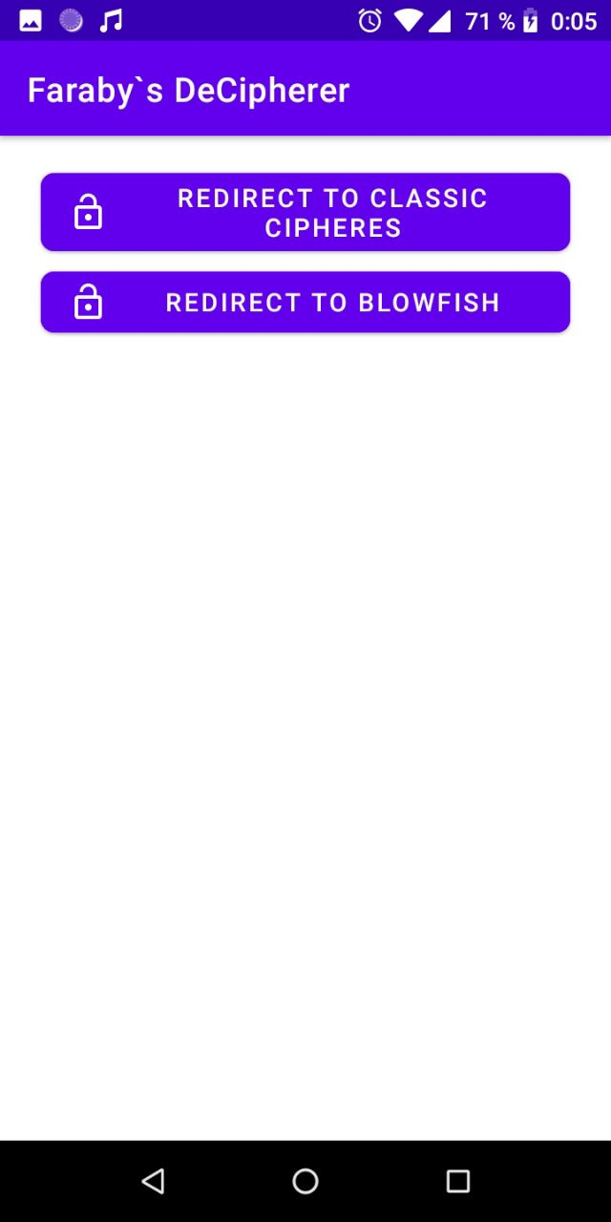

Encoding:

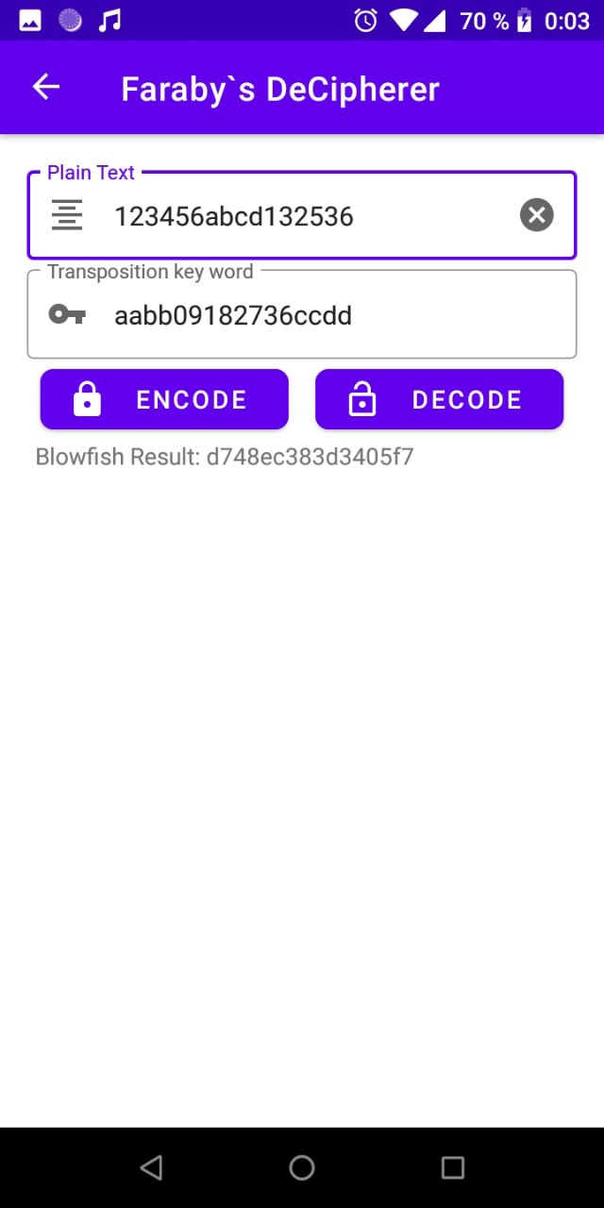

Decoding:

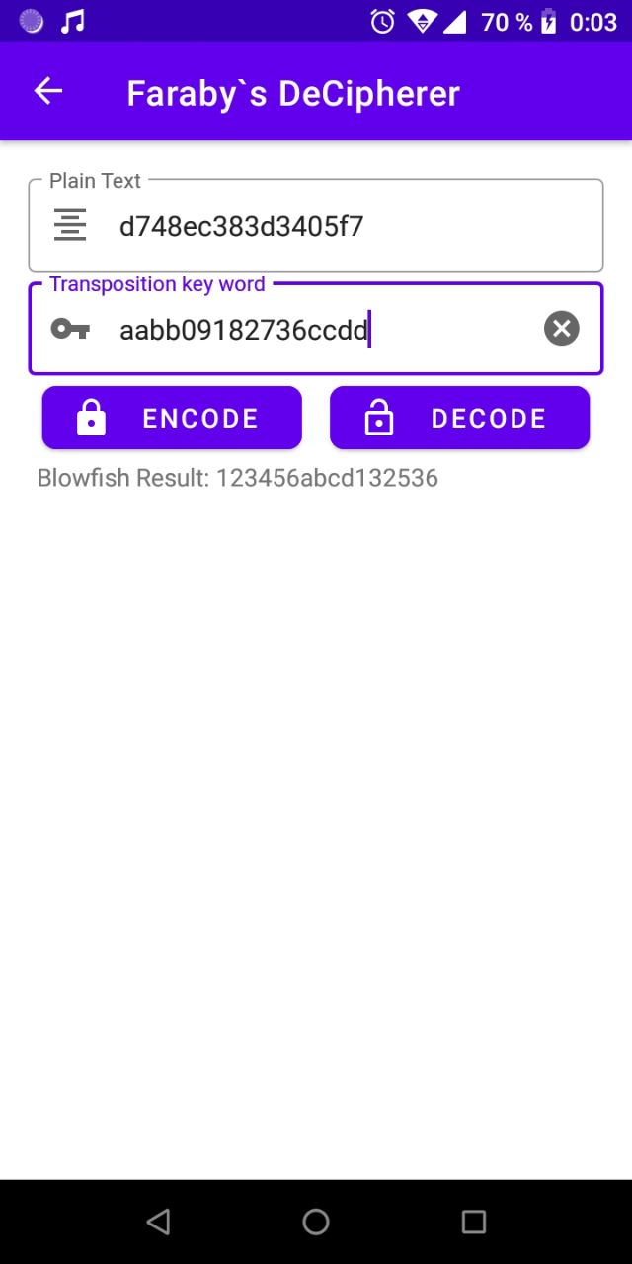

The S-boxes are stored inside the class:

